**LEGO Technic Supercars**

* I am a big fan of LEGO Technic and cars, and decided to design this website for the Capstone project to feature LEGO’s amazing supercar designs
* Source code: <https://github.com/leeping-ng/lego-supercars>
* Framework used: Bootstrap 4
* This webpage has 4 html pages:
  + index.html
  + bugatti.html
  + lamborghini.html
  + porsche.html
* Responsive design principles are used in all html pages, as seen from the desktop (left) and mobile (right) views in the following pages
* Enhancements added in addition to course materials:
  + Carousel with start/pause button for index.html
  + Font awesome icons for social media at footer
  + Block quotes above footers for 3 html pages, with famous quotes from car designers
  + Breadcrumb navigation for 3 html pages
  + Card showing ‘quick facts’ for 3 html pages
* All 4 html pages have been validated with no errors (screenshots at the end)

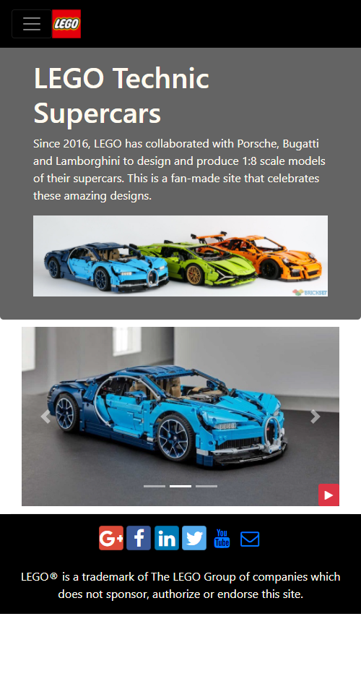**index.html**

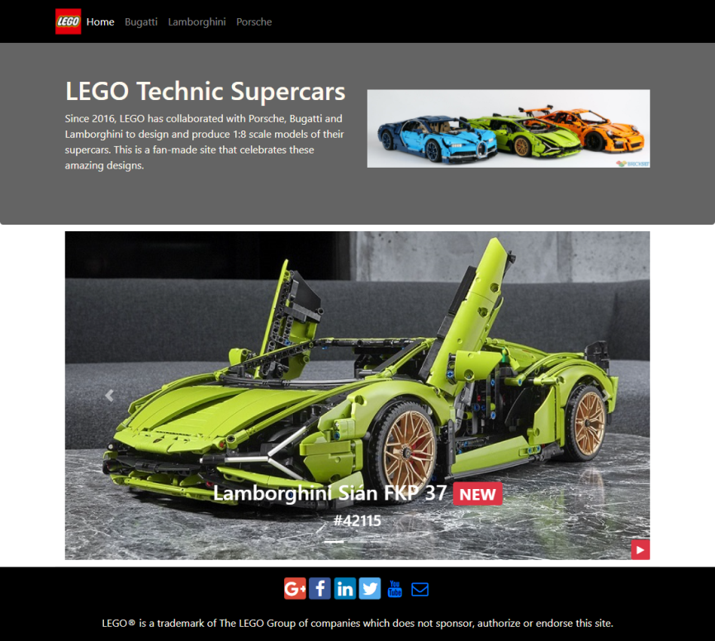

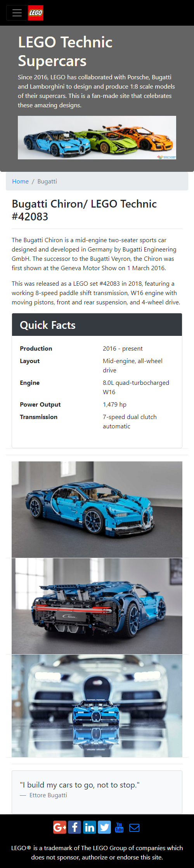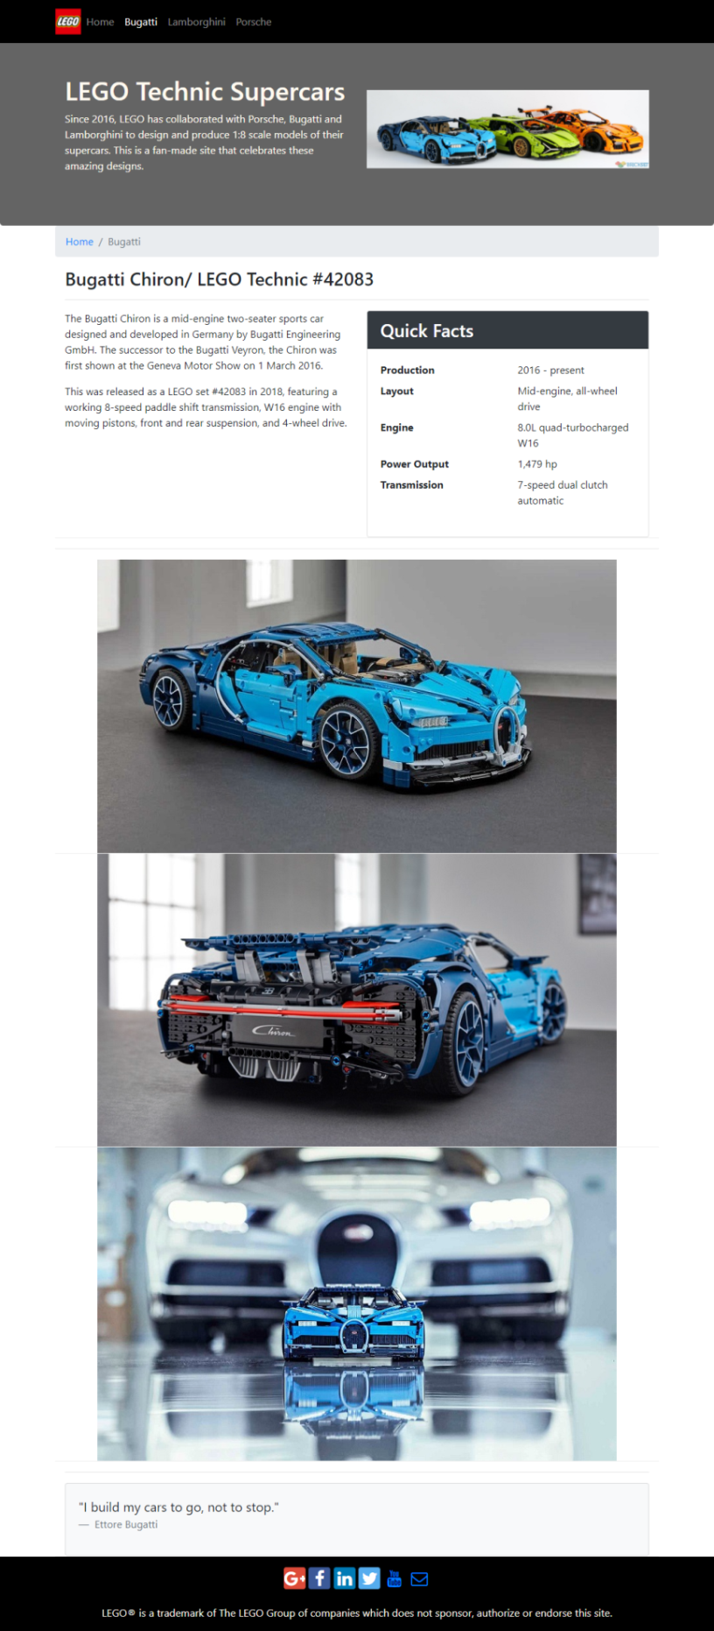**bugatti.html**

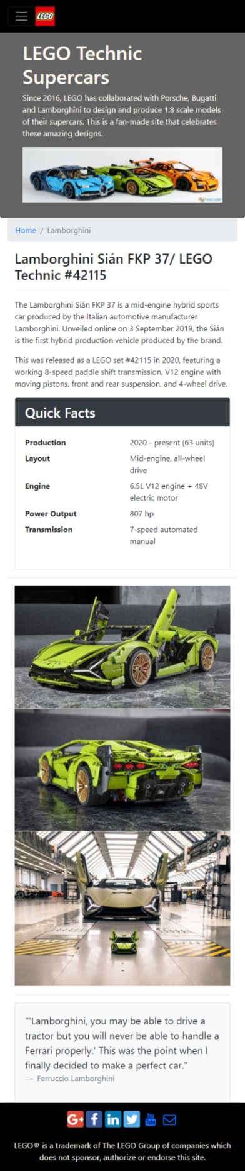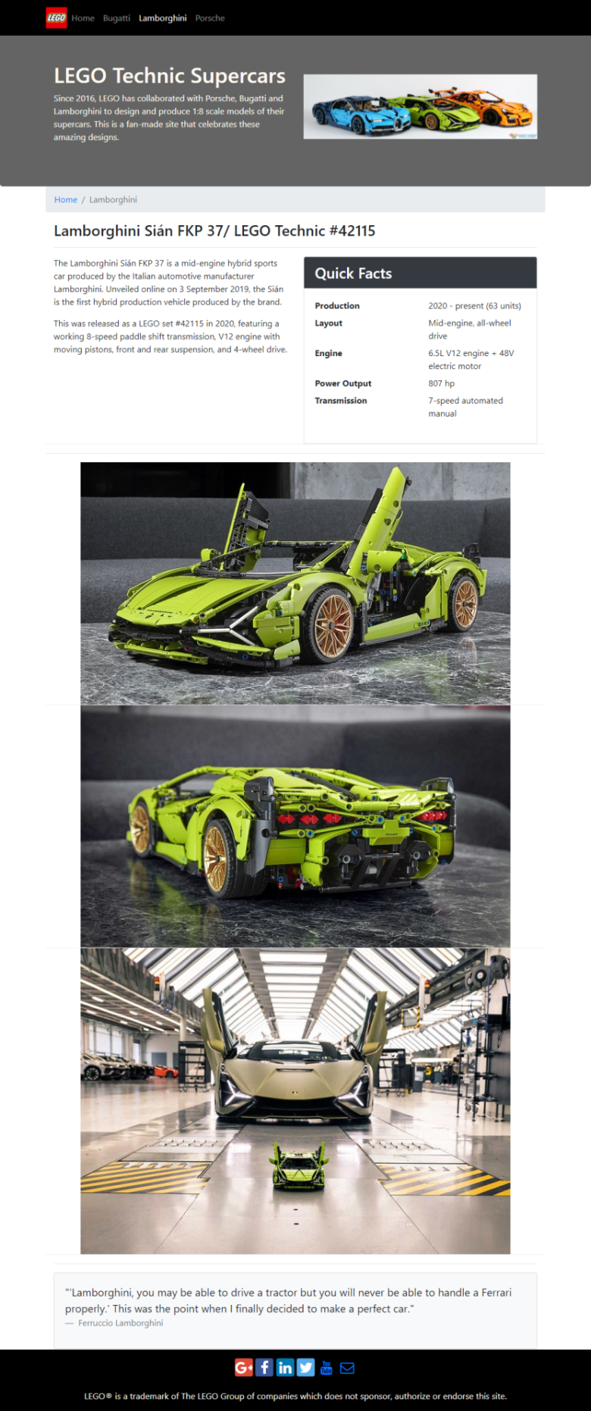**lamborghini.html**

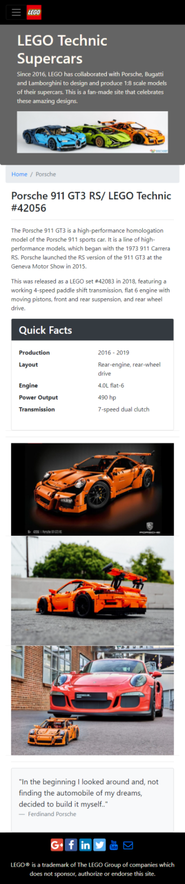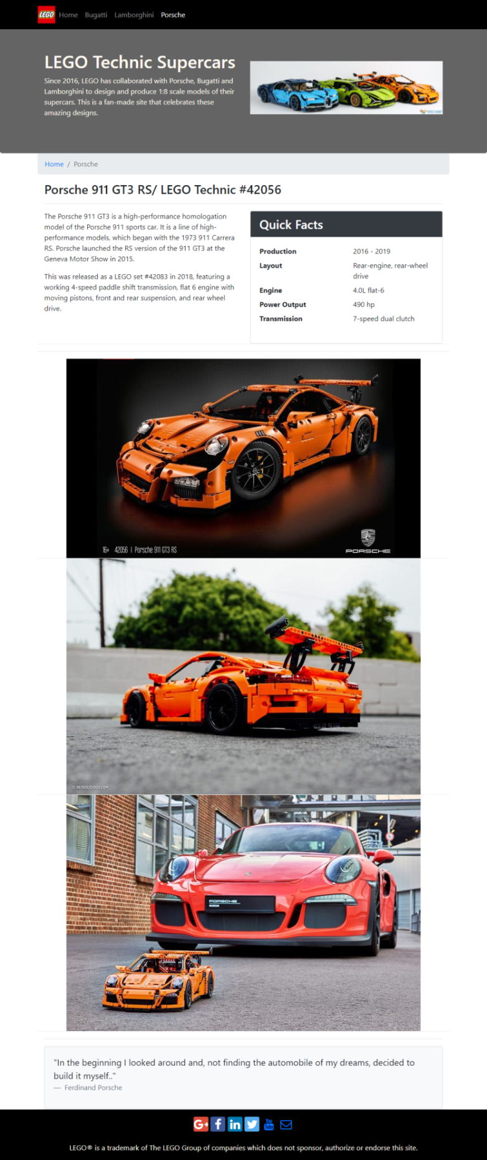**porsche.html**

**Validated index.html with no errors**

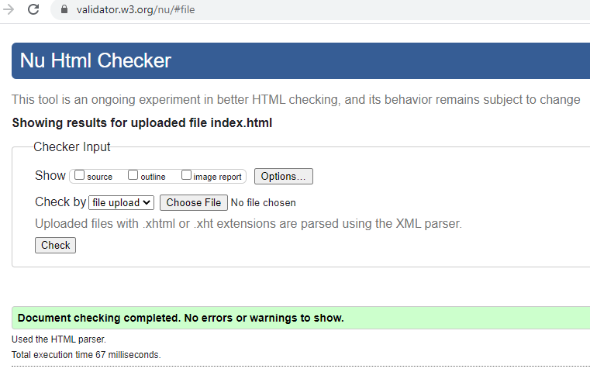

**Validated bugatti.html with no errors**

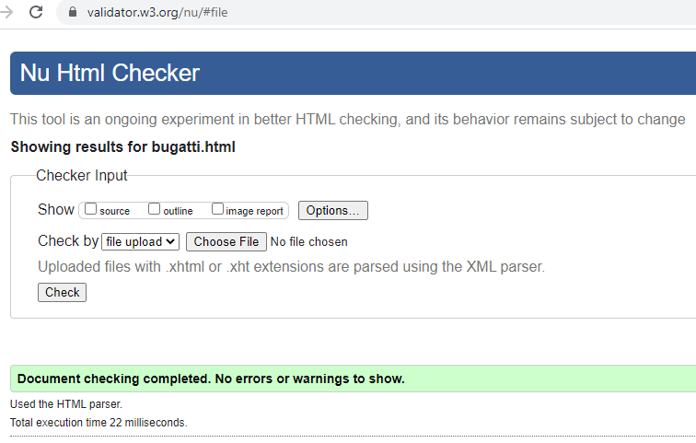

**Validated lamborghini.html with no errors**

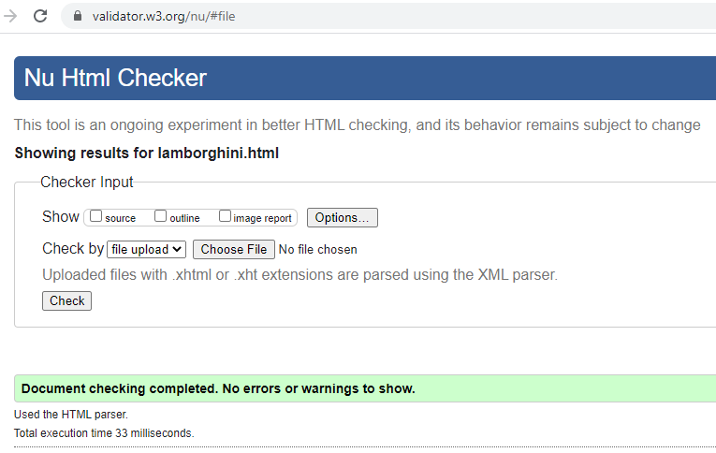

**Validated porsche.html with no errors**

